IoT Lab 1

**Name:** Cao Xinyang

**HDU Number:** 20321308

**My Photo:**



**Job issue for the work:**

Build your model including at least 3 intersections (without traffic lights

yet). Area to be modelled is nearby your home. Leave enough space for

traffic jams in approach to the crossroads.

**The map around my home:**

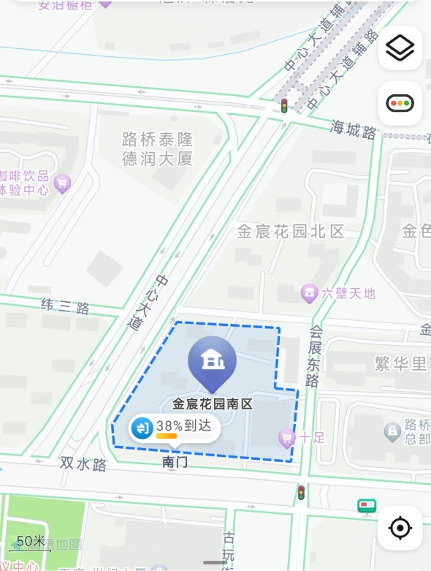

**The model I built:**

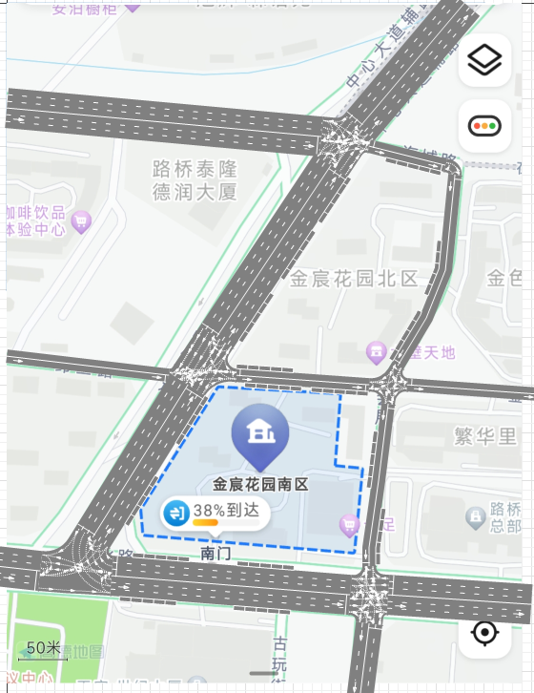

**Conclusion:**

During this lab, we have learnt how to use the software AnyLogic to build the model of the road. To build the model, you need to drag the module you want (such as road/intersection) to the map. On the right setting penal, you can adjust your parameters, such as number or width of lanes. After learning this part, it would be easy for me to build the model of cities, which is very useful.